

FAST National University of  
Computer and Emerging Sciences

Information Security

Assignment 2 – Test Report

* Name: Muneel Haider
* Roll No: 21I-0640

Contents

**Introduction:** 3

**Functional Testing:** 3

**1.** **Registration:** 3

**2.** **Login:** 3

**3.** **Chat:** 4

**4.** **Repeated Username Registration:** 4

**5.** **Incorrect Login Credentials:** 4

**6.** **Registered Users in creds.txt:** 5

5

**7.** **Server:** 5

**Security Testing:** 6

# **Introduction:**

This report highlights the functionality and security of the Server-Client question. The application utilizes Python sockets in order to accurately implement some fundamental concepts of Information Security. Some of these include Diffie-Hellman key exchange and AES encryption. The objective of this report is to validate system’s functionality, ensure secure data exchange and encrypted communication between two users.

# **Functional Testing:**

# **Registration:**

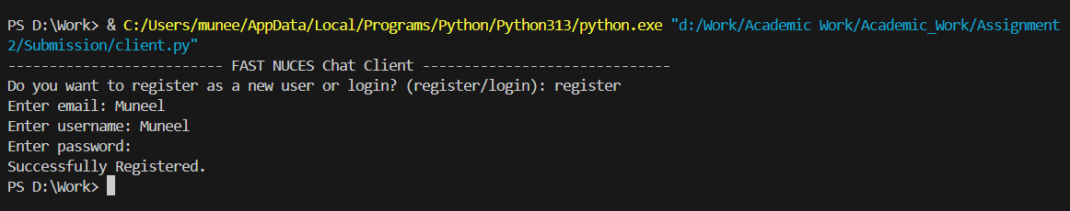

# 

# **Login:**

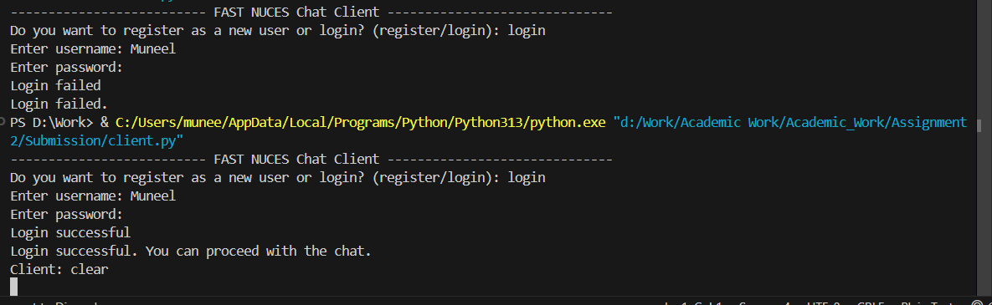

# 

# **Chat:**

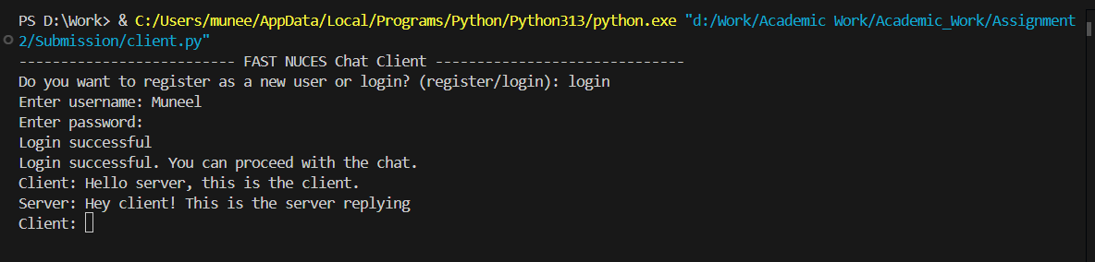 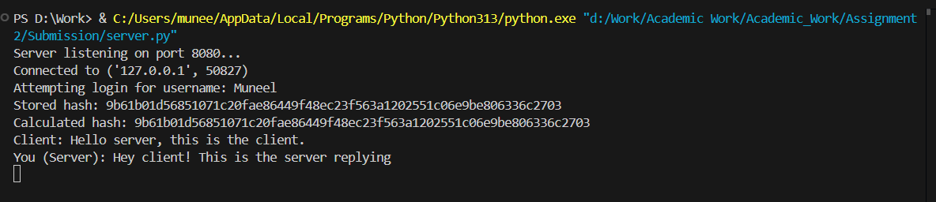

# 

# **Repeated Username Registration:**

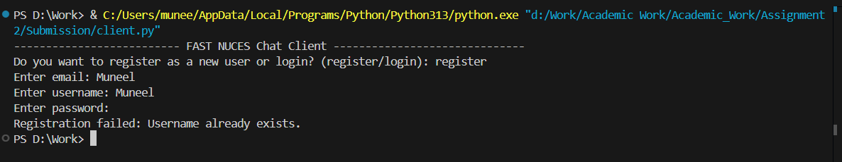

# 

# **Incorrect Login Credentials:**

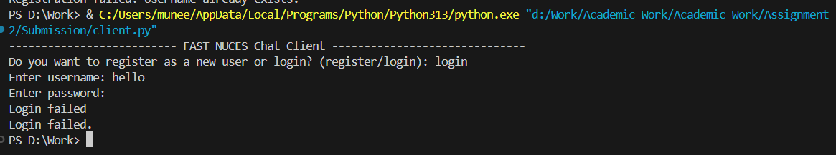

# **Registered Users in creds.txt:**

# 

# 

# **Server:**

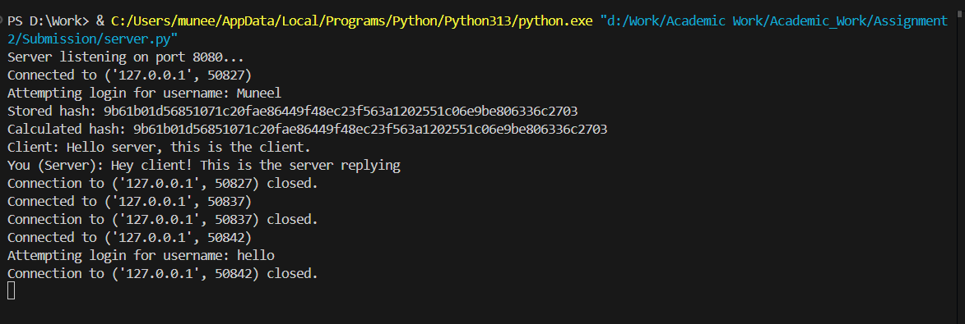

# 

# **Security Testing:**

# 